FOR IMMEDIATE RELEASE 1/15/20
Contact: center@partnershipway.org

Humberto Maturana and Ximena Davila Yáñez: the Biology of Love

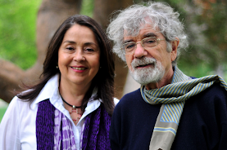
On 1/15/2020, the Center for Partnership Studies (CPS, California) awarded its second international prize honoring scholars who distinguish themselves in the dissemination of partnership studies in different fields of academic study and research to Humberto Maturana and Ximena Davila Yáñez for their pioneering, international work through Instituto Matríztica, now Escuela Matriztica de Santiago, on the biology of relationships and love, in alignment with partnership cultural principles.
Humberto Maturana’s work, along with his colleague Ximena Davila Yáñez, spans over 23 years and has been particularly focused on the biology of love. Their invaluable research at the Instituto Matríztico, now Escuela Matríztica de Santiago, has become an influential scientific contribution to our understanding of the biological-cultural nature of humanness.
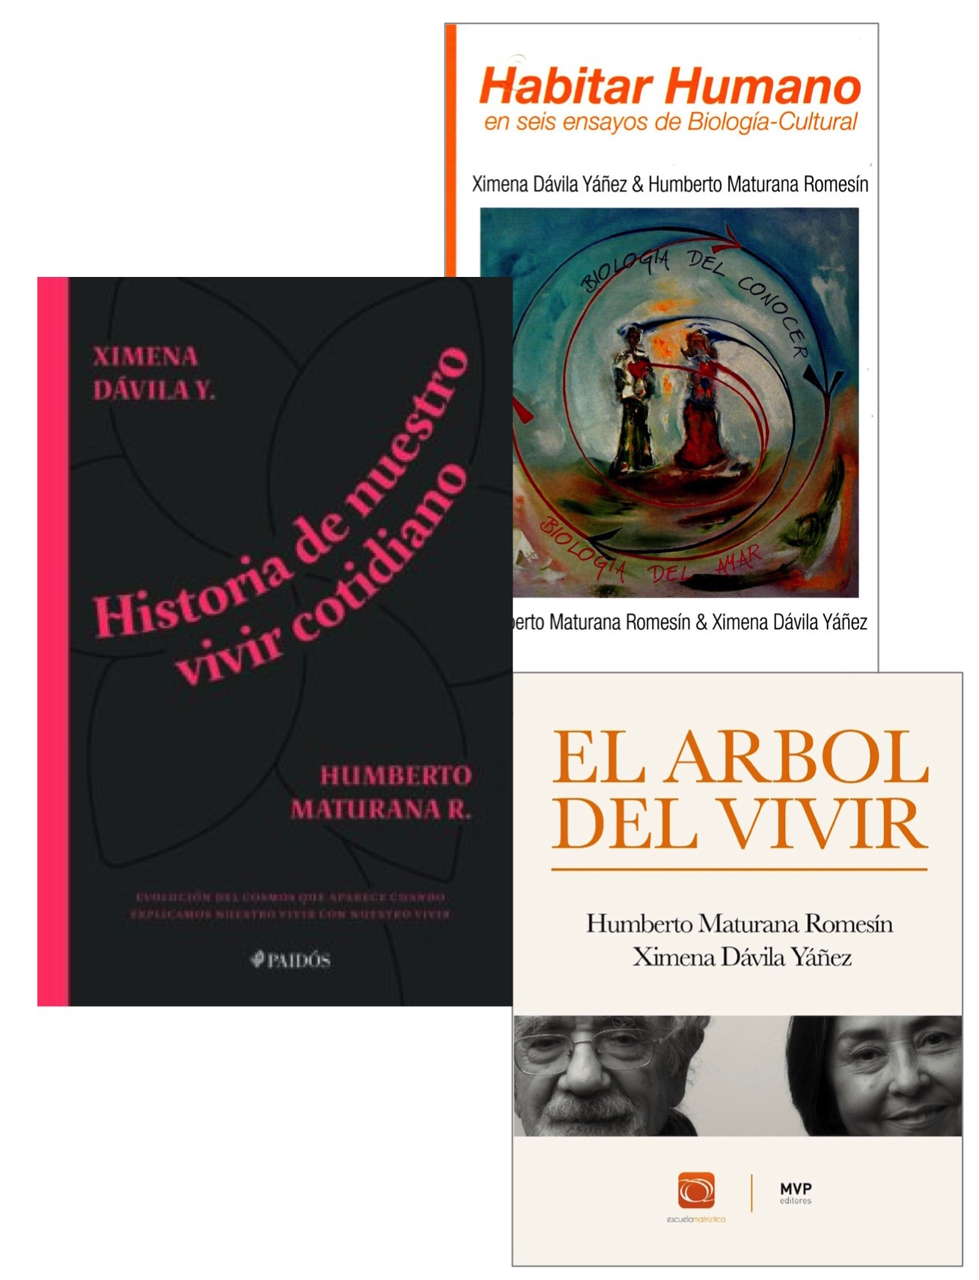
Maturana and Yáñez have published two ground-breaking books in Spanish, Habitar Humano en Seis Ensayos de Biología Cultural (2008) and El Árbol del Vivir (2015) in which they show how the emotion of love is operationally the fundament of the origin of living beings in the conservation of all molecular autopoietic systems. In accord with Riane Eisler’s partnership model, Maturana and Yáñez demonstrate how the evolutionary history of humanity is not centered on competition and aggressive striving but on love and cooperation.
In November of 2019, Humberto and Ximena released their latest book, "Historia de Nuestro Vivir Cotidiano" (History of Our Daily Living) in which they share—in a simple and profound manner—the basis and foundations of our human loving nature. This book should be released in English by the end of the year. The first edition in Spanish was sold out in a few months, so it promises to offer classic reading for curious people.
The Center for Partnership Studies Award was initially granted in 2018 to Antonella Riem from the University of Udine (Italy), for her pioneering contribution to World Literatures and Partnership Studies.
https://centerforpartnership.org/

